18.87: a) From Eq. (18.21),

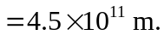

b) and the time between collisions is then about 20 yr. Collisions are not very important. c)
d) 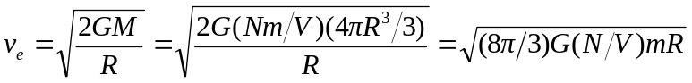
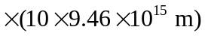
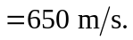

This is lower than 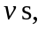and the cloud would tend to evaporate. e) In equilibrium (clearly not thermal equilibrium), the pressures will be the same; from 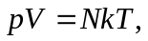
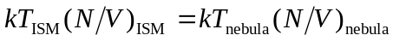
and the result follows. f) With the result of part (e),
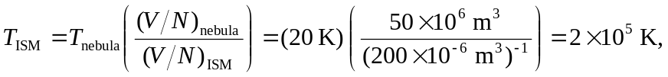
more than three times the temperature of the sun. This indicates a high average kinetic energy, but the thinness of the ISM means that a ship would not burn up.

